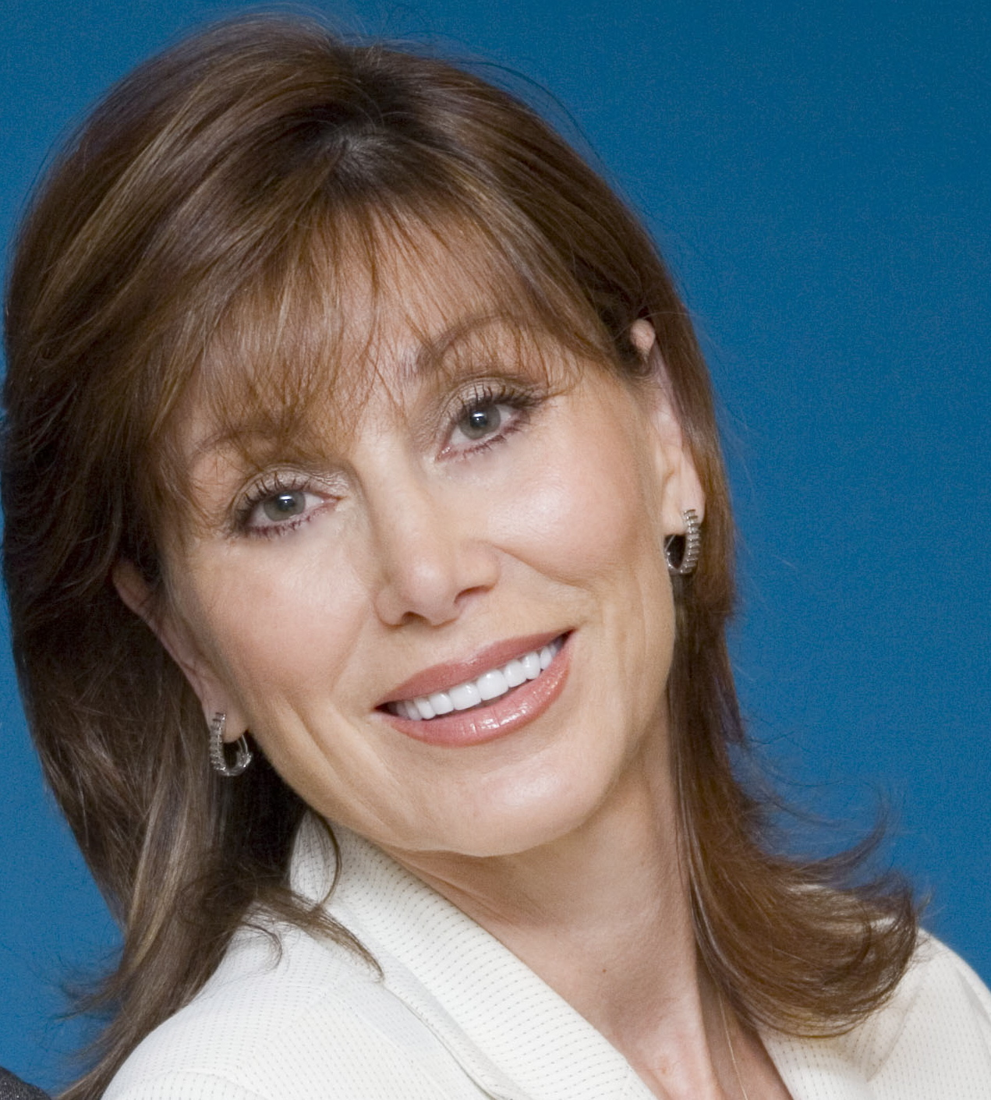
Dawn L. Billings, Inc.

PRE-PROGRAM QUESTIONNAIRE

Company/Association: ________________________________________

Meeting Date: _____________

This questionnaire is designed to help us prepare a tailored presentation. Feel free to complete this on your computer, however, please use the same numbers. Please answer all applicable questions and return NO LATER THAN ________along with the items checked in #23 to Dawn Billings at the address below.

Your Name is: Your Title is:

Your Email is: Your Web Page is:

1. Objectives / Goals: At the end of the program you'd like the attendees to "take action" or leave with ideas on "how to":

a.

b.

c.

2. Describe how you would like the attendees to “feel”, "be aware of" or "think differently".

3. What is the specific purpose and theme of this meeting (annual meeting, awards, etc.)?

4. What is the mission / philosophy statement for your organization or association? (If returning a copy of your statement – write “see enclosed.”

5. What are some current problems / challenges/breakthroughs experienced by your organization / industry? Any major changes or announcements I should be aware of?

6. What top challenges are your staff or association members currently facing? Are there morale issues that should be addressed?

7. What areas of participant performance need improvement or recognition?

8. Special jargon or terminology I should be aware of?

What issues or terms should I avoid?

9. Program Mix (Note: a. and b. should equal 100%):

a. Please spend _____% of your time delivering "how to" ideas with take home value.

b. Please spend _____% of your time delivering motivation, entertainment, stories.

10. a. # of Attendees_____ Avg. Age_____ % Male_____ % Female_____
b. Audience make-up: _____% Senior exec. _____% Mid-mgmt. _____% Board of Directors
_____% Officers/Sales reps. _____% Support/Clerical _____% Entrepreneurs_____ % Other
- Positions / job titles: Ethnic Diversity: ___ % Caucasian ____ % Asian ____ % Black ___% Hispanic_____ % Other
e. Educational Level: _____% H.S. Grad _____% College Grad _____% Masters/PhD

f. Any spouses / special guests:

g. Businesses only: _____ # of employees __________ assets/sales ______ # offices
Associations only: _____ # of members

11. Corporations, please list names, titles and telephone numbers of senior executives, line managers and / or employees I can contact to get additional inside information. Please provide names of contacts who reflect the greatest percentage of the audience make-up as noted above in question #10b and will be attending this meeting.

Associations, please provide names of individuals who have registered for your conference or some key committee members who will be in attendance.

- Name Title
Company________________________ Tel.( ) - Email

- Name Title
Company________________________ Tel.( ) - Email

- Name Title
Company________________________ Tel.( ) - Email

12. Name and title of senior executives or committee members present at this meeting:

- Name Title
Tel.( ) - Email

- Name Title
Tel.( ) - Email

13. Please list the people in your organization/association responsible for the following (If any listed in #12, write “see #12”):

- President/Exec. Director: Title

Tel. ( ) - Email

- V.P./Sales & Marketing: Title

Tel. ( ) - Email

- Training or Education Director: Title

Tel. ( ) - Email

14. To extend the impact of Dawn and Corbin’s message, would you like information about her learning materials? Association’s note: We can partner with you to create added value follow-up tools for your members and non-dues revenue for your association. _____ Yes _____ No thanks.

15. Will a video or audio taping crew be on-site?

_____ Yes _____ No If Yes, Company Name:

Contact: Tel. ( )

16. Previous speakers used:

Name Topic Year

Name Topic Year

17. Meeting Time: Begin_________End_________ My Program: Begin_________End________

Total # of attendees _____________

For breakouts only: estimated # of attendees in my session: ________

18. Name of my introducer:

Title __________________________________ Tel. # ( )_______________________

19. What takes place immediately before / after my program (speaker, meal, break, etc.)? If there will be another speaker, please indicate topic.

Before:

After:

Comments:

20. Meeting location: Address City_________ Zip ___________
Hotel Tel.#(_____)___________ Fax (______)__________
Address City Zip _________
Hotel Contact _______________________ Tel.#(_____)___________ Fax (______)__________
Closest Airport_______________________ # miles from site_______Travel Time __________

21. How can I best get from airport to site / hotel? Cab_______Limo_______Other______________

If someone is picking me up, please provide name: ____________________________________

22. If problems / emergencies arise on my way to program, who should I contact?
Name_______________________ Bus (_____)______________Home (______)____________

23. Please send me any of the following information you might feel is important for me to benefit you (if available):

___Mission / vision / values ___Training programs-table of contents
___Strategic plan / objectives ___Sample sales tracking and contact mgmt. reports
___Business / Marketing Plan ___Key product brochures + product knowledge
___Annual Report manual sample pages (3-4 products)
___Organization Chart ___Special promotions / campaigns
___Meeting agenda / invitation ___Informative articles
___Sample completed perf. appraisals ___Service measurement / feedback tools
___Association magazine / newsletters ___Sales & service recognition programs
___Staff / company newsletter / flyers ___Service standards
___Customer / member newsletters ___Job descriptions
___ 3 industry journals / magazines ___Association Member Directory
___ Association new membership ___Other
packet and profile

THANK YOU!

Dawn L. Billings, M.A.,LPC
3433 East Kenwood Street
Mesa, Arizona
918-605-1492
choosetobegreat@aol.com

